Wonder how long it will take all of us to get used to writing the new year—much less adapting to what the new year brings to each of us socially, personally, financially, environmentally. I sincerely hope this is a wonderful year for us all and the children we serve!
For those of us too busy to do more than skim the headlines, I need to draw your attention to two very important reminders:
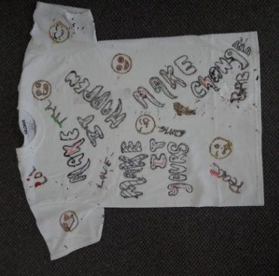
Please remember your Foundation’s Funding Committee is comprised of active GALs. When there is a question regarding your request, it is because they are Advocates and care greatly about your advocacy. Including every detail (size 5, female) you can and being specific (“I am asking for play clothes and a jacket—her favorite color is purple”) will expedite fulfillment.
The Foundation can NOT reimburse expenditures without PRIOR approval and individuals receiving funds MUST submit receipts within 30 days.
The GAL7 Foundation met the needs of Circuit 7 children last year with expenditures of $18,822.50! For the coming year, your Foundation will be focusing on raising funds to support the vital normalcy activities our children desperately need and legally deserve: tutoring, sports, after school programs, the arts and extra- curricular interests… summer activities…camps!! It is these normal childhood experiences which are the building blocks for healthy self esteem and appropriate social interaction.
Your 12 volunteer Board Members are asking all Circuit 7 GALs to search out these opportunities within your communities and let your local office liaison(s) know the contact information. Your Foundation is seeking to actively facilitate local partnerships and relationships enhancing children’s lives. Let’s be ready to have all our kids have the most dynamic and robust spring and summer breaks of their lives!
To that end, your volunteer Board will be asking for “Helping Hands” from time to time as we hold fund raising events in each of our five local communities. We need a cadre of people in each of our communities to help us facilitate an event on a given day. We promise to do our best to give everyone as much lead time notice as possible!
Looking forward to a most productive year; together we will eliminate generational dependency—one child at a time!
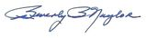
Sincerely,

President, GAL7 Foundation, Inc.
An Art Opportunity
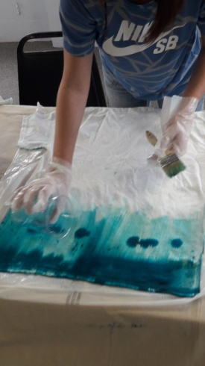
Sarah Carrigan, St. Johns GAL and Board Member, offers art workshops for families in our community including the children of our GAL cases through the Vilano Beach Art Program. They are held every second Sunday of the month. More details can be found at this website: http://www.vilanobeach.com
_________________________________________________
Thinking of purchasing a Honey Baked Ham for a special occasion?
By using this link Https://honeybakedfundraising.com/fundraisers/Help_send_kids_to_camp the GAL7 Foundation, Inc. will receive 20% from each gift certificate purchased. Use your Gift card for in store or online purchases and we all win.

GAL7 FOUNDATION, INC. is a 501 ( c ) ( 3 )
tax exempt charity organization.
A1A 72-Mile Garage Sale
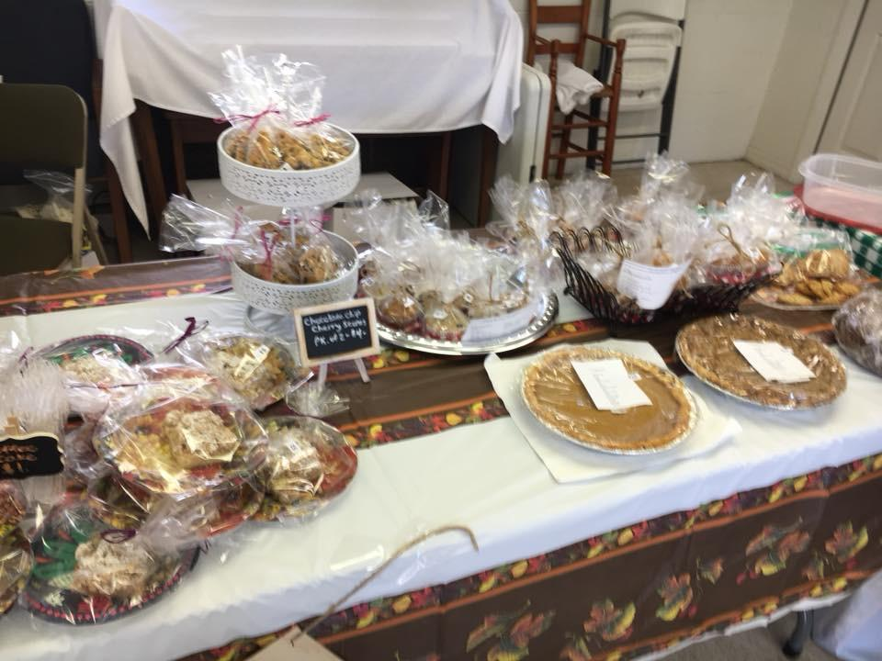
A yard sale, a bake sale and a hot dog, chips and water sale garnered $900.00 for our GAL kids at this fun annual event. Thank you to Fund Raising Committee member, Eileen Cederberg, for being a gourmet baker and Hammock Baptist Church for providing space. We plan a concession stand for next year.

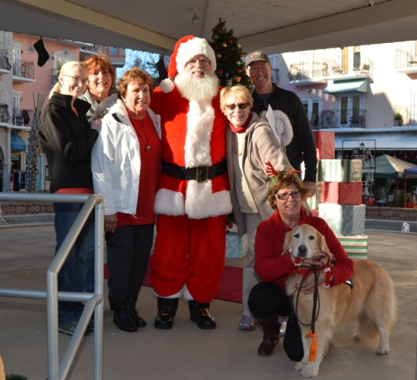
Santa Paws

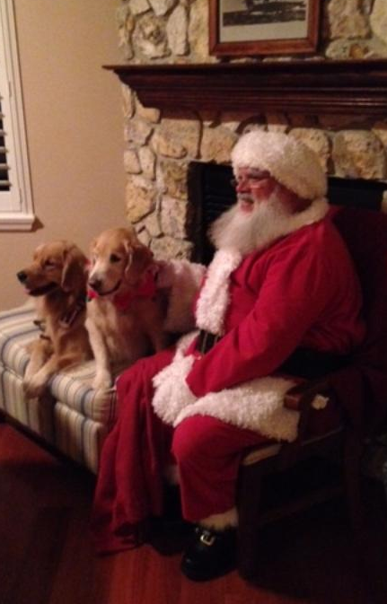

Dozens of “Pet Parents” brought their canines and
felines to Center Court at European Village to meet Santa and let him know what they wanted for Christmas. A few children stopped by, too. For a $5.00 donation, a 4 x 6 picture of the pet was taken with Santa in his big chair.. Hats off to Heather Thompson of HT productions for donating space in Center Court and messaging her friends and family to attend. And a BIG Thank You to Patrick Johnan (aka Santa). A pet parade for spring is in the works!
Pancakes, Pancakes

Rosie’s Café in Ormond Beach was the location for “Pancakes and Photo with Santa.” For the second year, Wesley Dunn, owner of Dunn’s Attic, and staff whipped up pancakes and donated the space. Circuit 7 staff Kim Taylor, Lauren Manville and Lauren Kinsey came to support this December fundraiser. Patrick Johnan, a professional Santa with a genuine white beard, listened carefully to each child’s wish. Thank you to folks who made free tickets available to the children and their caretakers.

Funding for 2018 has begun

The Rotary Club of Coastal St. Johns County Board of Directors unanimously approved supporting the GAL7 Foundation for the next three years. Each year, the club will give the Foundation $2,000. In exchange, we will fill some volunteer spots for their Tennis Tournament in April (exact dates to be confirmed).There will be a gala Saturday night at the Fountain of Youth. More details to follow. If you want to lend a “helping hand” to fill spots, contact Deborah Dunning at debdunning@hotmail.com or at 812-369-1554.

The Frank V. Oliver, Jr. Endowment (administered by the Community Foundation for Northeast Florida) has awarded another grant to the Foundation. This $4,000 will be available to meet the needs (basic and enrichment) of Putnam County’s children in Dependency Court who have a GAL.

Calendar of Events:

March 19, 2018 - Table 1 (known for casual cuisine, great wine and live music) in Ponte Vedra will be location of our first fundraiser of 2018. Tickets are $25.00 and the event lasts for one and a half hours. Included in the ticket price - a wine and food sampling in the bar area. At the end, we will remit $5.00 per guest who attends the event – we keep the rest of the funds collected from ticket sales! Many guests stay at Table 1 for a full dinner and chat with friends.

Events are in the planning stage for May and fall. Information to follow. Last year, our funds raisers added over $9,000 to our budget.

"A COPY OF THE OFFICIAL REGISTRATION #CH42750 AND FINANCIAL INFORMATION MAY BE OBTAINED FROM THE DIVISION OF CONSUMER SERVICES BY CALLING TOLL-FREE (800-435-7352) WITHIN THE STATE. REGISTRATION DOES NOT IMPLY ENDORSEMENT, APPROVAL, OR RECOMMENDATION BY THE STATE."

